2016 WOMEN’S HEALTH RESEARCH DAY
Title of Poster: Hepcidin-mediated iron restriction during pregnancy results in adverse pregnancy outcomes
Presenter: Veena Sangkhae Institution: UCLA DGSOM Center for Health Sciences
☐ Faculty ☐ Fellow ☐ Resident ☒ Post-doc Research Fellow ☐ Graduate Student ☐ Medical Student ☐Other
Principal Investigator/Mentor: Elizabeta Nemeth, PhD Co-Investigators: Tomas Ganz, MD, PhD
Thematic Poster Category: Basic Science Research
Abstract

Iron deficiency is associated with adverse effects on fetal development and maternal health including increased maternal morbidity and mortality, preterm birth, low birth weight, cognitive defects in newborns, and impaired immune function. Unfortunately, the prevalence of iron deficiency remains extremely high worldwide and despite its importance, little is known about the basic physiology of maternal and fetal iron regulation during pregnancy. Hepcidin is the central iron-regulatory hormone and functions as a negative regulator of total body iron and plasma iron levels. It acts by degrading its cognate receptor, Ferroportin (Fpn), the only known mammalian iron exporter, to prevent both the absorption of iron from the diet and release of stored iron into the circulation. Of note, Fpn is also expressed on placental trophoblast where it transports iron into fetal circulation, but because it is localized facing fetal circulation, placental Fpn is not under the direct control of maternal hepcidin. In normal pregnancy, maternal hepcidin levels are suppressed to allow for greater iron absorption and mobilization from stores, and thus increased iron supply to the placenta and the fetus. However, inappropriately elevated maternal hepcidin during pregnancy, which can occur in inflammatory conditions including infections and autoimmune diseases, may impair placental and fetal iron status.

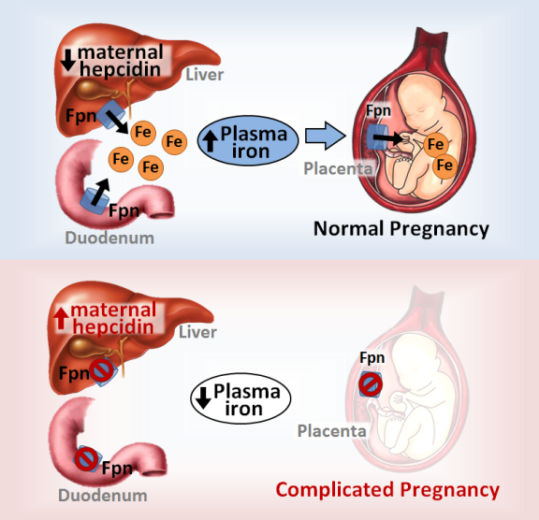
Here, we administered a bioactive hepcidin peptide mimetic to pregnant mice during the second and third trimester, to model a condition of elevated levels of maternal hepcidin. The hepcidin mimetic caused severe maternal iron restriction resulting in anemia in mothers and pups, low birth weight, and even increased mortality of mouse embryos. Interestingly, we also observed that in states of maternal iron restriction caused either by low dietary iron or by high maternal hepcidin, placental Fpn was downregulated, further preventing iron transfer from the placenta to the fetus. These surprising results support a model where low maternal serum iron results in active restriction of iron transfer to the fetus, supporting maternal over fetal health. Iron supplementation is common during pregnancy; however improperly elevated maternal hepcidin would render the supplementation ineffective. Further studies are underway to determine to which extent elevated maternal hepcidin resulting from inflammation or infection is responsible for the adverse pregnancy outcomes associated with those conditions.
Figure 1. Maternal hepcidin levels determine iron supply to the fetus during pregnancy.

