**2016 WOMEN’S HEALTH RESEARCH DAY**

**Title of Poster:** Indifferent partner relationships during pregnancy are related to lower Interleukin (IL)-13 in child’s cord blood at delivery       
**Presenter:** Dr. Kharah M. Ross **Institution:**

Faculty  Fellow  Resident  Post-doc Research Fellow  Graduate Student  Medical Student Other   
  
**Principal Investigator/Mentor:** Dr. Christine Dunkel Schetter   **Co-Investigators:** Dr. Judith Carroll, Dr. Gregory Miller, Dr. Ann Borders  
    
**Thematic Poster Category:** 

**Abstract**

Background: The inflammatory arm of the immune system plays key regulatory roles during pregnancy. Altered maternal inflammatory activity is thought to increase risk for adverse pregnancy and child outcomes. Previous work suggests that partner relationships low in social support (help and listening) and low in social negativity (conflict and guilt), that are referred to as “indifferent” relationships, were associated with the lowest level of IL13, an anti-inflammatory cytokine, in maternal blood during twhe second and third trimesters of pregnancy [1]. Additionally, maternal inflammation over pregnancy may be transmitted to neonate circulation; for example, greater maternal IL13 over pregnancy predicts greater neonate IL13 in cord blood at delivery [2].

Purpose: To determine whether maternal relationship with her partner over pregnancy predicts IL-13 in neonate cord blood at delivery.

Methods: A sample of 49 pregnant women were studied during the second and third trimesters of pregnancy. Partner social support and social negativity were reported by the mother using the Quality of Relationships Inventory [3], then averaged over both assessments. Maternal demographics (age, race/ethnicity and socioeconomic status) and lifestyle factors (pre-pregnancy BMI, smoking status) were also recorded. Vein umbilical cord blood samples were taken at delivery. Neonate anti-inflammatory cytokine IL13, along with other inflammatory markers, was measured using electrochemiluminescence.

Results: Women were on average 31 +/- 5.5 years old, 62% White and 21% Black, and had completed 15.4 +/- 2.1 years of education. Linear regression models were used to predict cord blood IL13 levels from averaged maternal reports of her partner’s support and negativity. A marginally significant support x negativity interaction emerged, *b* = -.107, *SE* = .055, *p* = .056. The Johnson-Neyman technique [4] was used to decompose the simple slopes. As shown in Figure 1, partner relationships characterized by the mother as low in support and low in negativity were associated with the lowest anti-inflammatory IL13 in cord blood at delivery, as compared to mothers with other relationship characterizations. Observed results persisted when controlling for maternal demographics and lifestyle factors.

Conclusions: Partner relationships low in both support and negativity over pregnancy according to mother reports (referred to in the literature as “indifferent”) are associated with lower anti-inflammatory IL13 in neonate cord blood at delivery, as compared to partner relationships high in both or high in one and low in the other. This pattern parallels earlier associations observed in this sample, where partner relationships low in support and negativity predicted low IL13 in maternal circulation during pregnancy. Taken together, our findings provide preliminary support for the possibility that maternal experiences of close relationships over pregnancy can “spillover” or be reflected in a neonate anti-inflammatory marker at birth, suggesting that maternal psychosocial experiences may be “shared” with the fetus via this altered circulating cytokine pathway during pregnancy. Future research is needed to assess “spillover” mechanisms and pathways.

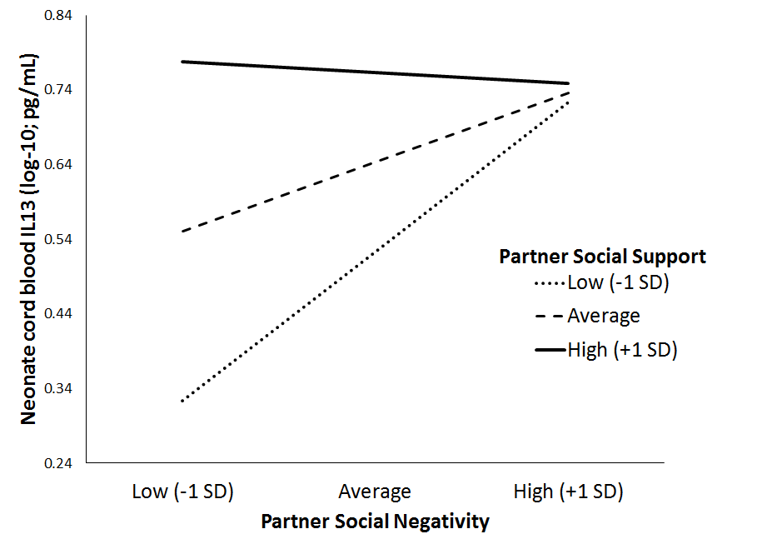

Figure 1. Maternal reports of support and negativity with her partner over pregnancy predict anti-inflammatory IL13 in neonate cord blood at delivery. Specifically, lowest neonate levels of anti-inflammatory IL13 are associated with low support and low negativity. Simple slopes of RP social negativity on neonate IL13 are significant for standardized values of RP social support less than -.323 standard deviation units (*b* = .127, *SE* = .063).

References:

1. Ross, K.M., et al., *Positive and negative aspects of the romantic partner relationship and peripheral inflammation over the second and third trimesters of pregnancy.* UNDER REVIEW.

2. Ross, K.M., et al., *Patterns of peripheral cytokine expression during pregnancy in two cohorts and associations with measures of inflammation in cord blood.* UNDER REVIEW.

3. Pierce, G.R., *The Quality of Relationships Inventory*, in *Communication of Social Support: Messages, interactions, relationships, and community*, B.R. Burleson, T.L. Albrecht, and I.G. Sarason, Editors. 1994, SAGE Publications Inc.: Thousand Oaks, CA. p. 247-266.

4. Preacher, K.J., P.J. Curran, and D.J. Bauer. *Simple intercepts, simple slopes, and regions of significance in MLR 2-way interactions*. 2003; Available from: <http://quantpsy.org/interact/mlr2.htm>.